Setting up Repository

Security keys setup

1. Generate your ssh key pair:
   1. Open git bash

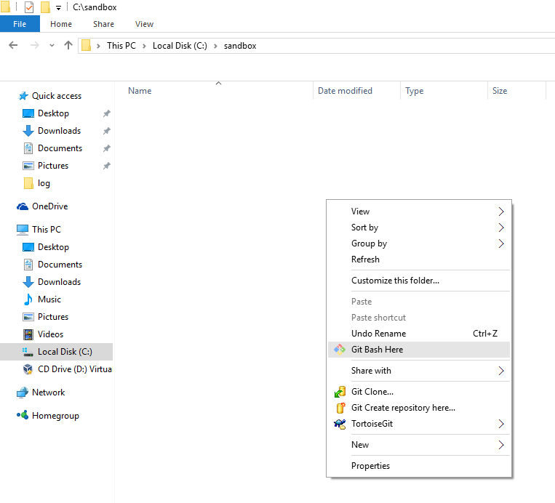

* 1. Execute ssh-keygen. All defaults, no passphrase.



1. Open file c:\Users\<Windows Username>\.ssh\id_rsa.pub in editor of your choice (notepad) and copy file content into clipboard (Ctrl-A, Ctrl-C).
2. Open you github profile settings page: <https://github.com/settings/profile> and select SSH and GPG keys.

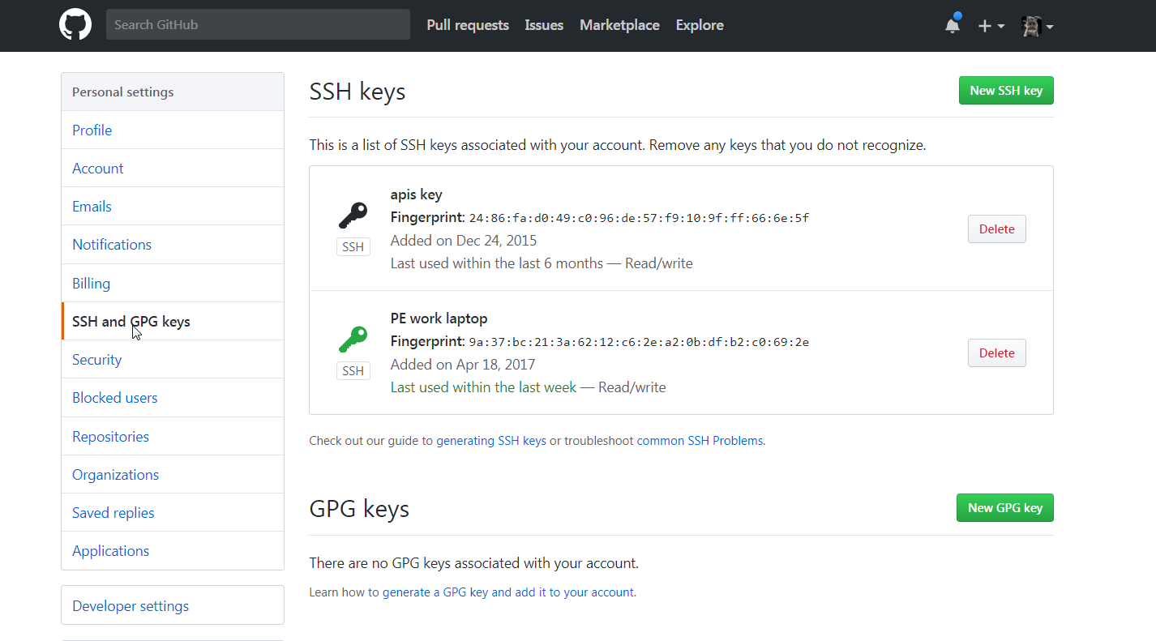

1. Add new SSH key

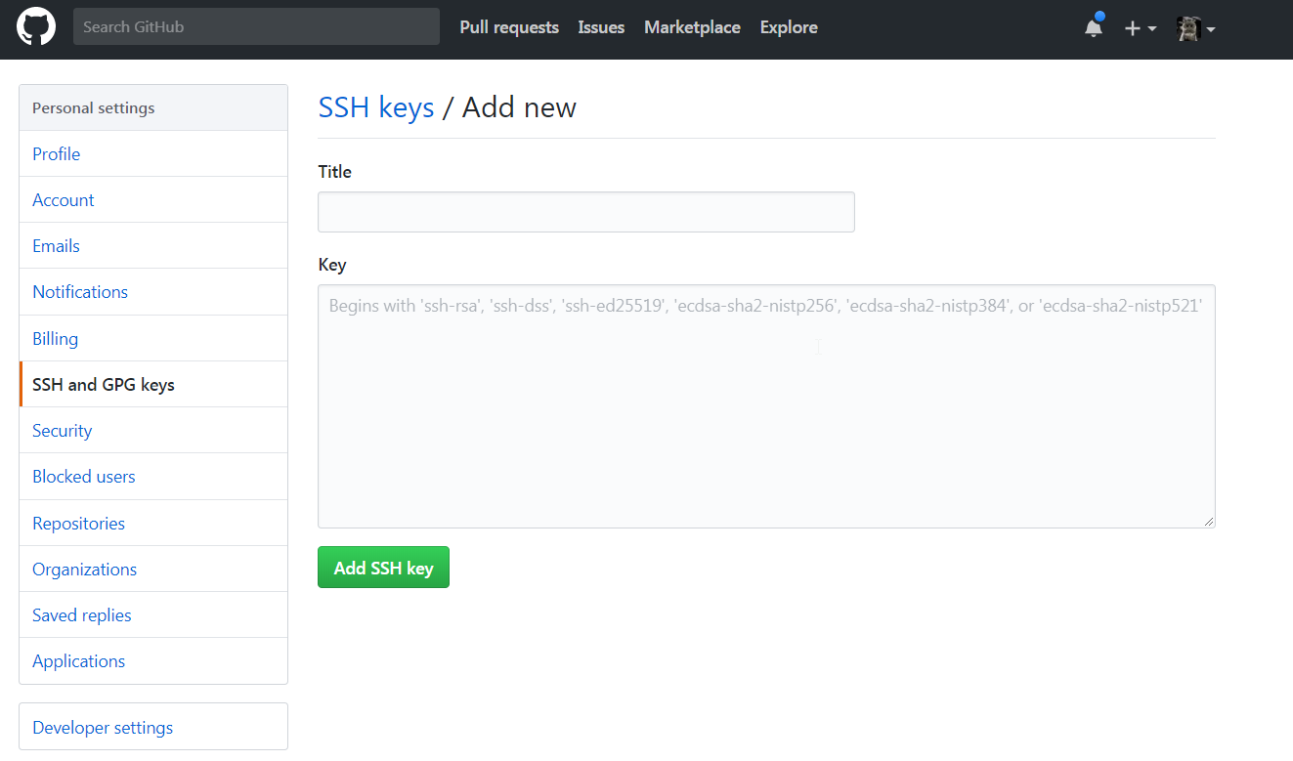

1. Paste public key content into key edit field.

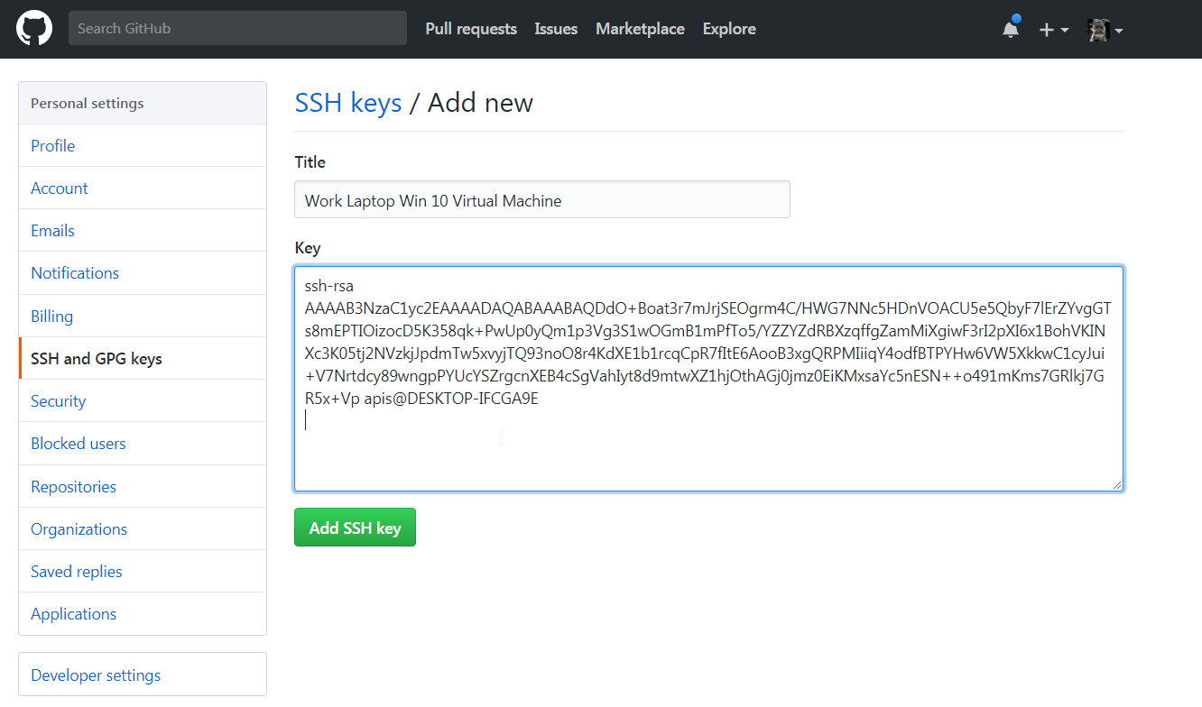

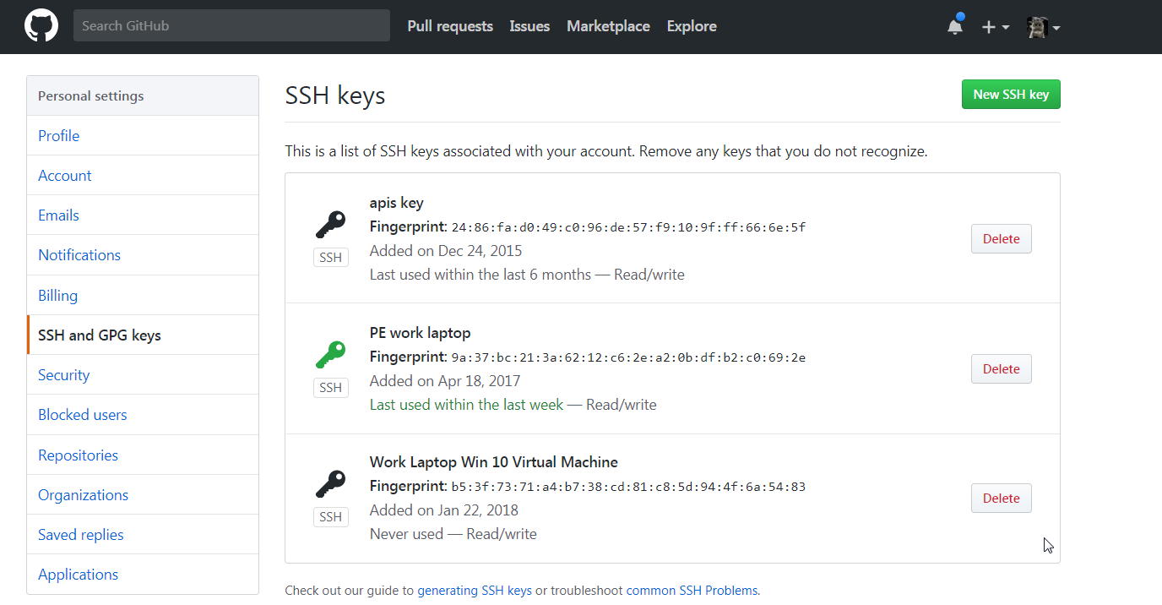

1. You finished your security key setup.

Repository cloning

1. Create folder where you will store your repositories, recommended location C:\sandbox



1. Open git bash in this location



1. Copy repository URL into clipboard, ensure that Clone with SSH is selected.

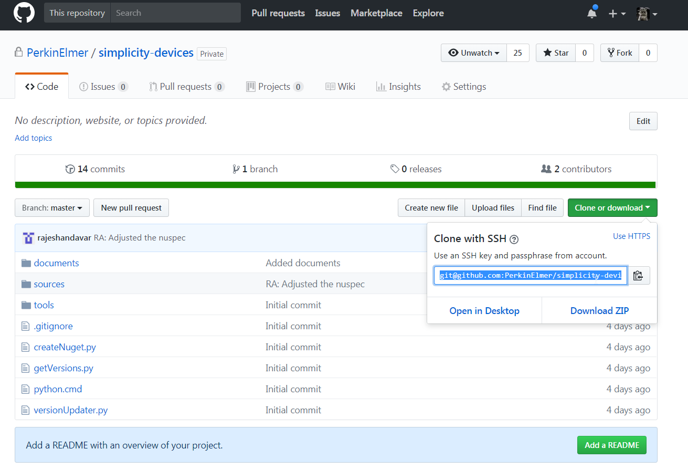

1. Type command: git clone and paste repository URL into bash command line. Execute it.

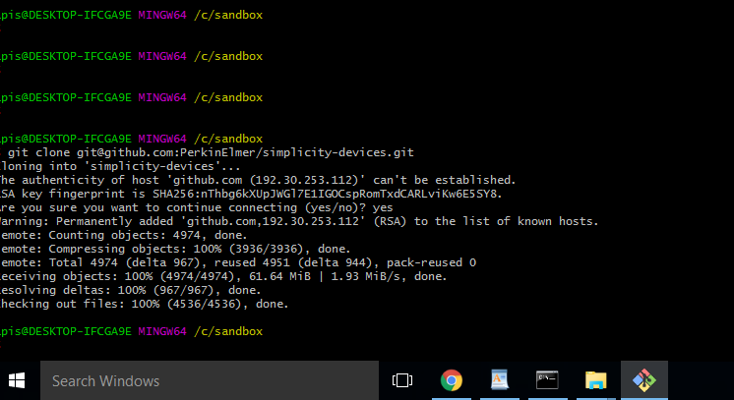

1. Congratulations you successfully connected to github and cloned your repository!